Chapter 7, Problem 8.

For the circuit in Fig. 7.88 if v = 10e^{-4t} V and i = 0.2e^{-4t} A, t > 0

(a) Find R and C.
(b) Determine the time constant.
(c) Calculate the initial energy in the capacitor.
(d) Obtain the time it takes to dissipate 50 percent of the initial energy.

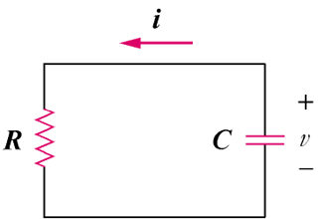

Figure 7.88
For Prob. 7.8.

